Chapter 4 – Fundamental

**Chapter Objective**

* Understand the basis idea of basic android programing through a weather forecast app

**Architecture**

* Linux Kernel
* Libraries
* App framework
* Application

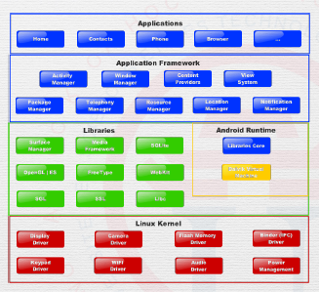

**Compilation**

* From source to device

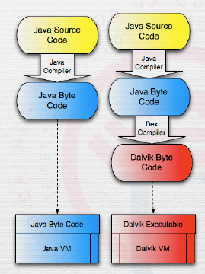

* Android virtual machine

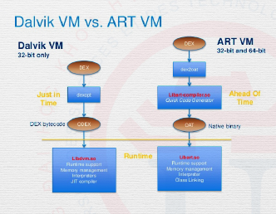

**Context and application**

* **Context**-Central command center  
  -Access application-specific data  
  -System services
* **Application**-A context  
  -Can be sub classed  
  -Global data

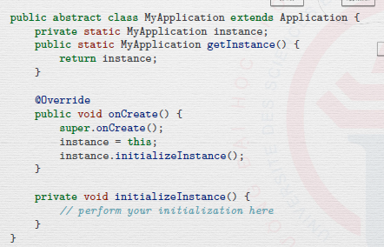

-Early initialization

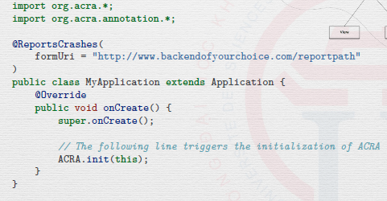

-Android memory management

-Android manifest

**Activity**

* activity control 1 ui
* Android has 0 Main() function from java, just activity
* Activity lifecycle:   
  +onPause()* -partially hidden  
  +onStop() -hidden  
  +onDestroy()  
  +onResume()*  
  +onStart()  
  +onRestart()  
  +onCreate()*  
  ….

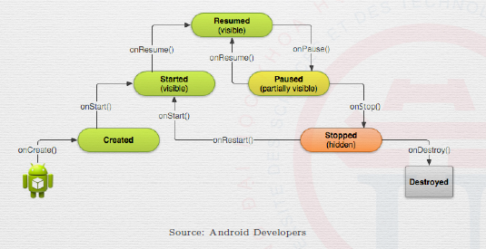

-onCreate():initialization, choose the view you want to control

-onPause(): stop animation or heavy task, save the unsave, release resource

-onResume():

-onDestroy()

-onRestoreInstanceState(): restore the activity to its previous state

-finish(): close current activity

Intent

Log: to debug purpose, to write thing yourself or just to report that function has performed on the android monitor.

**Fragment**

* To help adapting with the screen size (phone, tablet…)
* To represent a behavior of part of interface
* Optional
* Divided info into building block
* **Fragment lifecycle**:  
  -similar with activity but not need view()
* **Fragment class:**-DialogFragment  
  -ListFragment  
  -PreferenceFragment (setting)
* **Activity with fragment**  
  -simplified   
  -coordinates fragment   
  -user Fragment manager
* **Create fragment:**  
  -use XML layout   
  OR  
  -code  
  +create fragment  
  +add fragment to activity

**View**

* What user interact with
* Basic building block if the interface
* XML, or dynamic code
* Attribute
* Padding and margin
* Text view
* Image view
* View group
* button